A PRELIMINARY REPORT ON

“Online Book Shopping”

SUBMITTED TO THE EDUBRIDGE INDIA PRIVATE LIMITED

SUBMITTED BY

Miss. Kiruthika S Batch No: EON-5755

### Under The Guidance of

Amruta Deore



### DEPARTMENT OF S PRAYAS CERTIFIED JAVA FULL STACK DEVELOPER 02

THANE

EDUBRIDGE INDIA PRIVATE LIMITED

2021-2022.

### ACKNOWLEDGMENT

It gives all of us great pleasure in presenting the preliminary project report on “**Online Book Shopping**”. With due respect and gratitude we would like to take this opportunity to thank internal guide of our project Mrs.Amruta Deore for giving us all the help and guidance we needed. We are really grateful for his kind support. She has always encouraged us and given us the motivation to move ahead. She has put in a lot of time and effort in this project along with us and given us a lot of confidence. Also we wish to thank all the other people who have helped us in the successful completion of this project.

Miss. Kiruthika S

### ABSTRACT

Online Book Shopping means when a user visiting the website can see a wide range of books arranged in respective categories. The user may select desired book and view its price. The user may even search for specific books on the website. Once the user selects a book, he then has to fill in a form and the book is booked for the user. This brings us the comfort to sit at any place and purchase any book that we want to read. This also saves our valuable time and gives us a wide options to choose from at one stop.

The Customers can connect to the Internet through the computer or mobile phones into this online bookstore and then check the book information, if they need to purchase select their books, should register their details, payment operation to achieve online transactions and submit order to complete the entire book ordering process.

Chapter 1

# INTRODUCTION

# 1.1 INTRODUCTION

The Purpose of this Online Book Shopping provides customers with online shopping facility through a web browser. Using this project the user can purchase books instead of going out to a book store. This project is to make a full functional online book store system that allow its users to search and purchase a book online based on category, author and subject. A customer can create login to his account, sort books by their category, place books into a shopping cart and pay bill using his credit card details and also with some more payment options. The administrator will have additional functionality when compared to the common user. He can add, delete and update the author, publisher, book categories, book details, member information and also confirm a placed order. Online book Store is developed using HTML, CSS, Javascript programming language.

# 1.2 OBJECTIVE

The main objective of this Online Book Shopping System is to make manual system to computerized system. This system will provide the customers to find their books in which they are willing to read, by search option and also can check the availability of a book either by using the book title or by using the name of author. It simplifies the task and reduce the paper work.

AdditionalIy, unlike a store, online shopping has friendly customer service representatives available 24 hours a day also where customer can visit our site anytime to view the availability of books, choose any of them and can order by paying online or can opt for cash on delivery as well. The administrator will regularly add any new books available to them for sale.

SYSTEM REQUIREMENTS

## 1.3 SOFTWARE REQUIREMENT

Operating System - Windows 7

Platform – Visual Studio Code

Client Side Scripting:

* HTML
* CSS
* JavaScript

HARDWARE INTERFACE

* SERVER-:Processor – Intel Core Family,
* RAM – 8 GB
* Disk Space – 500 GB

WEB BROWSER

* Chrome

# UML DIAGRAMS

## 1.4 Use case Diagram

The following UML use case diagram shows the working of an Online Book Shopping. The use cases for the user are; Login, Create Account, Search Book, Place Order, Registration, Payment, Logout. The administrator, on the other hand, can Login, Add or delete category, Add or Delete Books, Manage Order, Add or Delete User and Logout.

USER Use Case Diagram

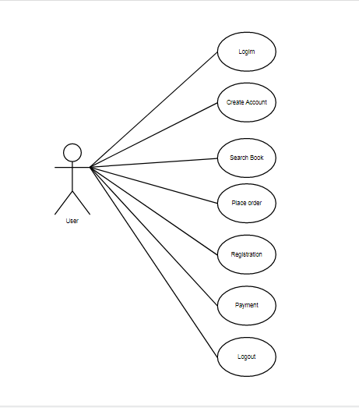

ADMIN Use Case Diagram

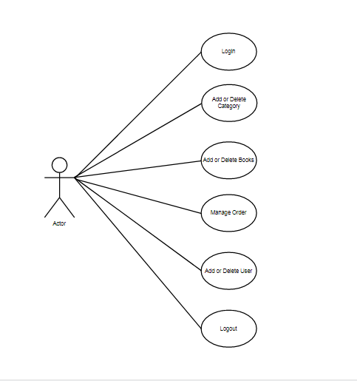

# 1.5 MODULE

## 1.5.1 Login

Login page will allow user to login through their account using their registered email-id. If the user does not contain account they can register for a new account.

• <form class="loginform" >

<h2>LOGIN</h2>

<label id="user1">USER NAME :</label><br>

<input type="text" placeholder="Enter Email-id" required><br/><br>

<label>PASSWORD :</label><br>

<input type="password" placeholder="Enter password" required><br/><br>

<a href="Homepageprofile.html"><button type="button" style="background-color: rgb(107, 141, 73);color:azure" onclick="myLogin()">Login</button></a><a href="Homepage.html"><button type="button" style="background-color: rgb(107, 141, 73);color:azure; margin-left: 10px;">Cancel</button></a><br/>

<a href="forgetpassword.html"><p>Forget Your Password?</p></a>

<p>New Customer?</p><a href="createaccount.html"><p>Create Account</p></a>

</form>

# 1.5.2 Registration

This module will helps the user to register for new account from anywhere. After successful registration the user can update information and change their password using reset password when required.

• <form class="formid">

<p style="font-weight:bold; padding-left:50px;">CREATE &nbsp ACCOUNT</p>

<label>Mobile Number</label><br/>

<input type="tel" pattern="[0-9]{3}-[0-9]{2}-[0-9]{3}"required/><br/><br>

<label>Email-id</label><br/>

<input type="email" required/><br/><br>

<label>Password</label><br/>

<input type="password" required/><br/><br>

<label>Conform Password</label><br/>

<input type="password" required/><br/><br>

<a href="LoginPage.html" style="padding-left:80px;"><button type="button" style="background-color: rgb(116, 172, 60); color:white" onclick="myAccount()">Register</button></a>

<p style="padding-left:35px;">Already have an account?</p>

<a href="Loginpage.html" style="padding-left:90px; color:rgb(141, 185, 51);">Login</a>

</form>

# 1.6 ADVANTAGES

* Customers can get their book delivered instead of actually going and buying the book. Eco-Friendly: paperwork can be avoided.
* They can make payment online itself.
* This System saves both time and travelling cost of customers.
* User can get to know different kinds of books that they were unaware of by just searching in the system or mobile phones.
* Global availability

Chapter 2

PROJECT IMPLEMENTATION

# 2.1 SCREENS

Home page

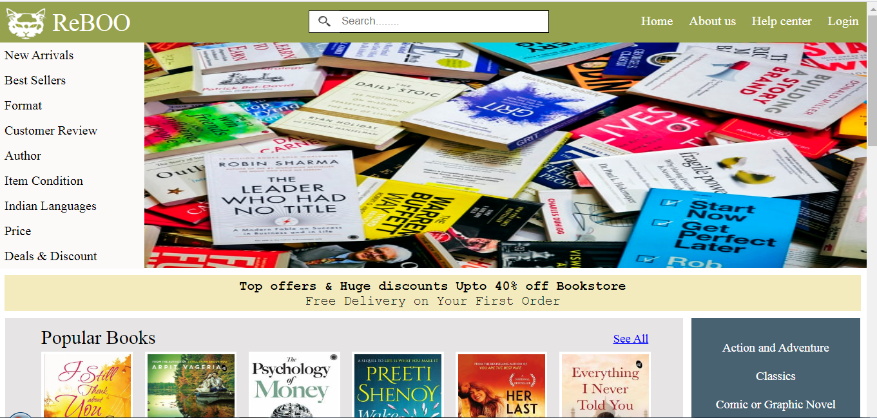

Login page

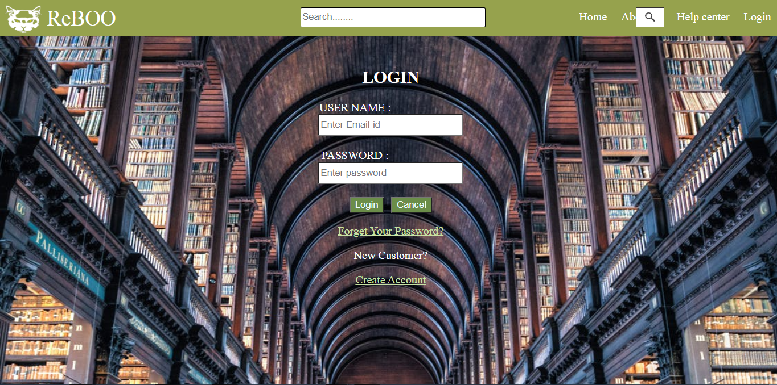

Registration page

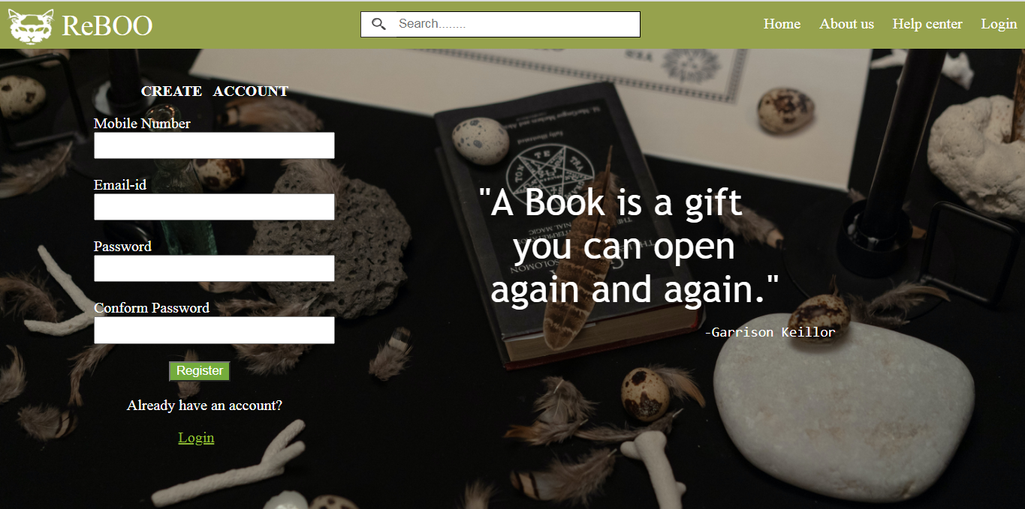

Book details

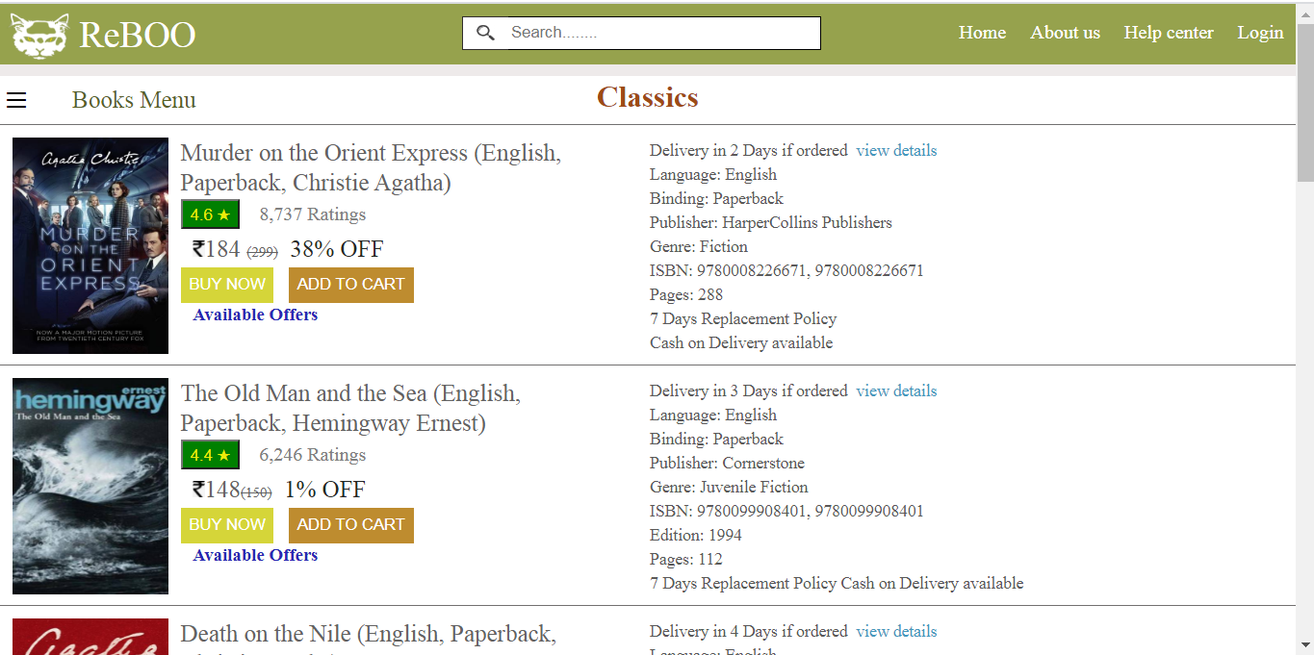

Place Order Page

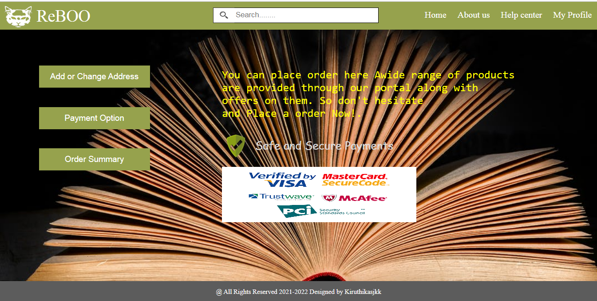

# 3. CONCLUSIONS

# 3.1 CONCLUSIONS

Online Book Store is an online web application where the customer can purchase books online. The Customers can connect to the Internet through the computer or mobile phones into this online bookstore and then check the book information. Through a web browser the customers can search for a book by its title or author, later can add to the shopping cart and finally purchase the books. In future this project is expandable if we can include more modules to it, like shipping and door to door delivery tracking.